The Role of Parent Child Relationship, Birth Order and Type of Family in Moral Development and Emotional Competences among Adolescent
A Synopsis Submitted to

Children’s University, Gandhinagar
Center of Education
Department of Research Program

For the Degree of Doctor of Philosophy
in
Psychology
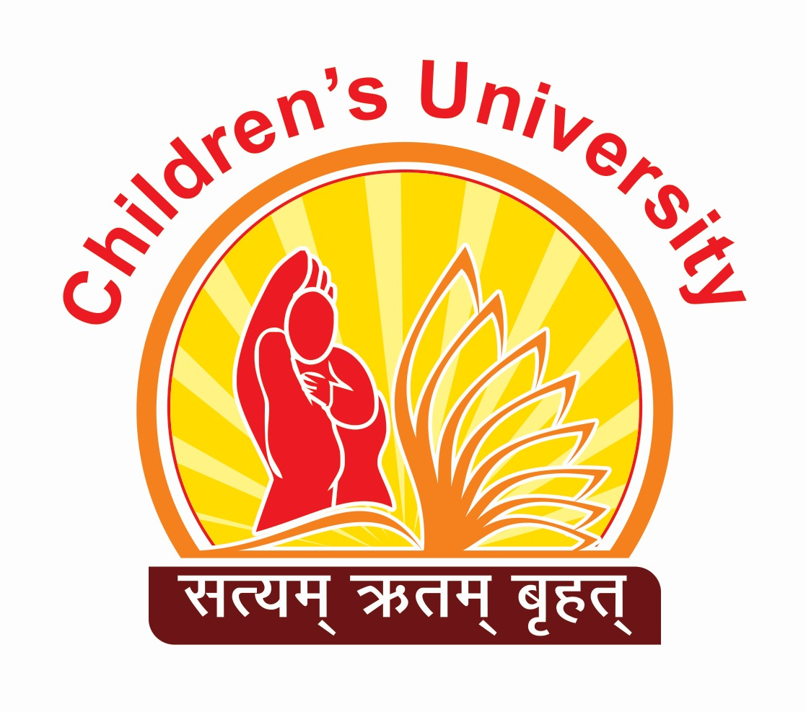

By
Nisha R. Chauhan
Under the Guidance of
Prof. B. D. Dhila
Professor of Humanities
Center of Education
Children’s University
Gandhinagar

Registration No: 102000498 Registration Date: 25/11/2020

December, 2023

